**12.How to do indexing and slicing in python?**

**Objective:**

* To implement the concept of indexing and slicing in python3.

**Process:**

* **Indexing.**

Every data type in python3 like list,tuple variables stores numbers, strings and characters.

Every element that starts with index 0.

**Positive index:**

Its starts with left to right with positive index number.

**Negative index:**

Its starts with right to left with negative index number.

Eg.

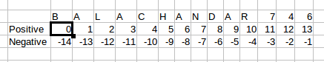

* **Slicing.**

we can call multiple element in a list or tuple or any other data type in python by creating a range of index numbers separated by a colon [x:y]:

**Input:**

* List data type.

**Output:**

* New list after slicing and indexing has been done.

**Source code:**

#simple list and tuple data type

list1=['bala','naren','vivek','sathish',10,45,85,20]

tuple1=('bala','naren','vivek','sathish',10,45,85,20)

list2=["banana","mango","jackfruit"]

print("******Indexing examples******")

#positive indexing

print(list1[0])

#negative indexing

print(tuple1[-1])

print("******Slicing examples*******")

#slicing

print(list1[0:6])

print(tuple1[2:5])

**Screen shots:**

